Test Case: tc001_SPX_Dev5_Crear_Requisicion_Spot_Tipo_Cobro_CC
Step 1 - Enter username and password and click to button Enter : Credentials Entered
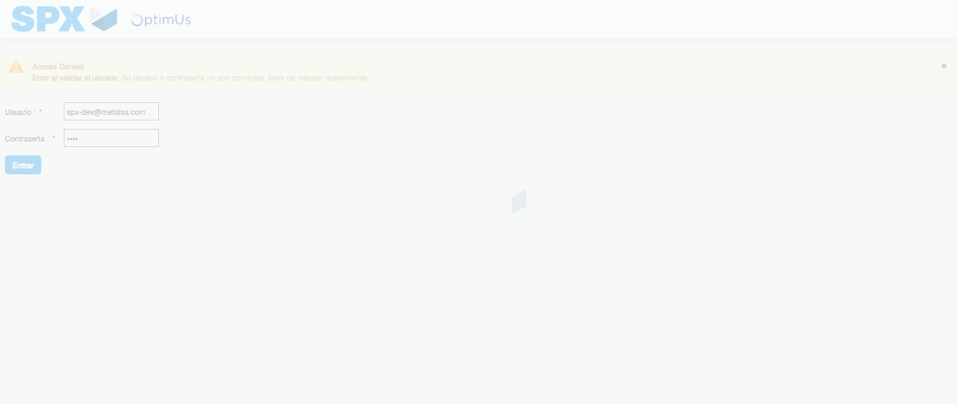Image file-name: QC_Testing-tc001_SPX_Dev5_Crear_Requisicion_Spot_Tipo_Cobro_CC-1788297698251

Step 2 - Select to UEN and Access to Spot Buy Requisitions : UEN Correctly selected and Correct access
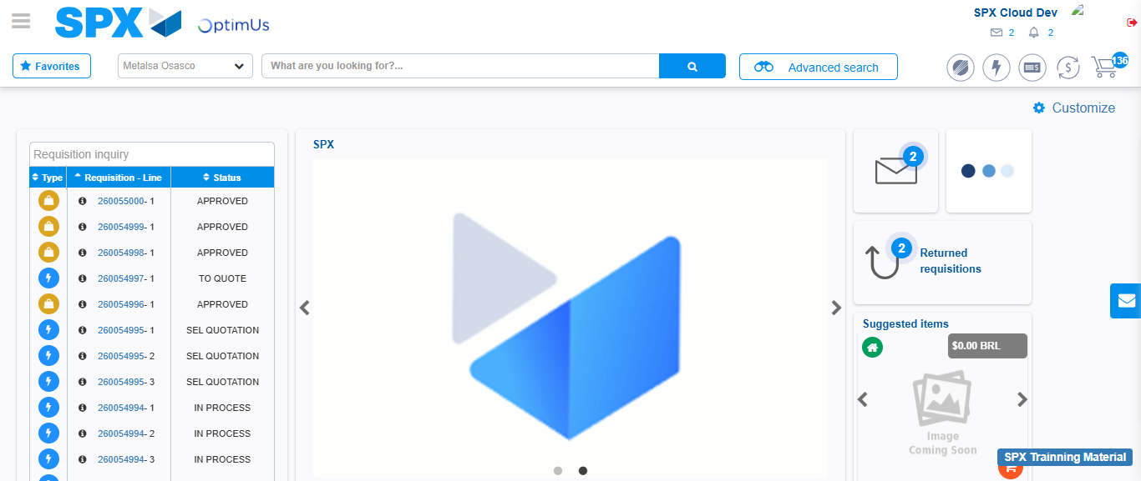Image file-name: QC_Testing-tc001_SPX_Dev5_Crear_Requisicion_Spot_Tipo_Cobro_CC-1788297723867

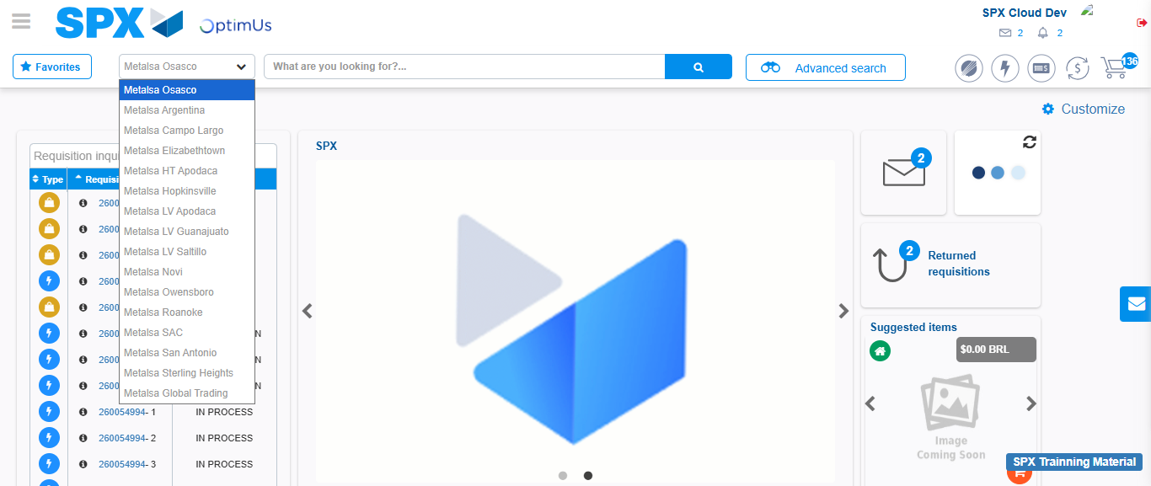Image file-name: QC_Testing-tc001_SPX_Dev5_Crear_Requisicion_Spot_Tipo_Cobro_CC-1788297724552

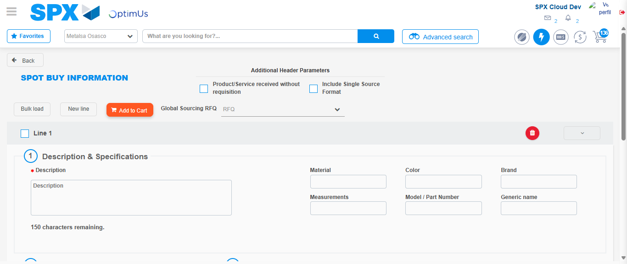Image file-name: QC_Testing-tc001_SPX_Dev5_Crear_Requisicion_Spot_Tipo_Cobro_CC-1788297746781

Step 3 - Data Capture Spot Buy Requisition : Data captured correctly
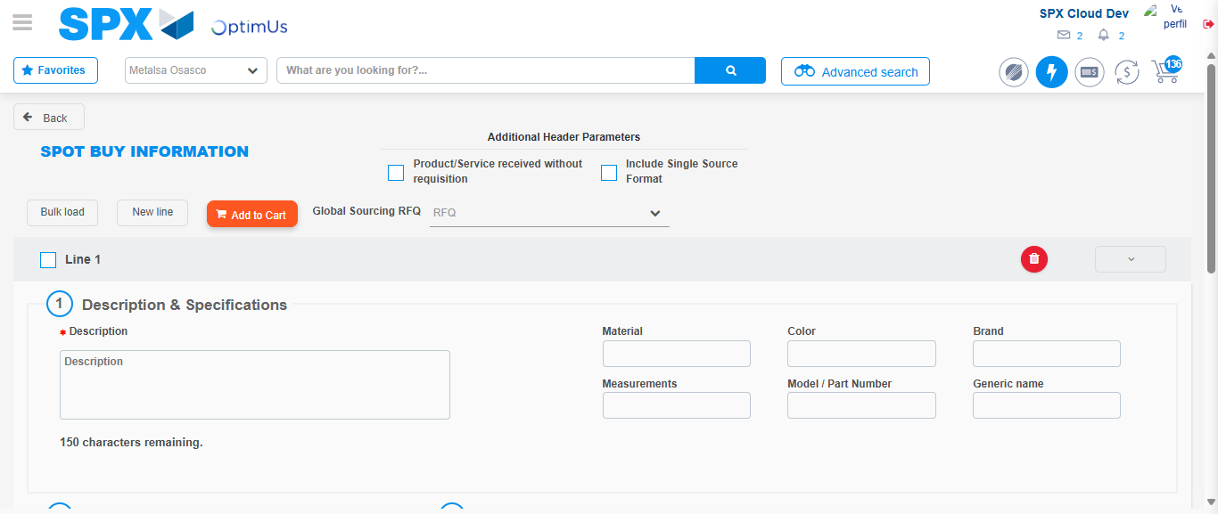Image file-name: QC_Testing-tc001_SPX_Dev5_Crear_Requisicion_Spot_Tipo_Cobro_CC-1788297747101

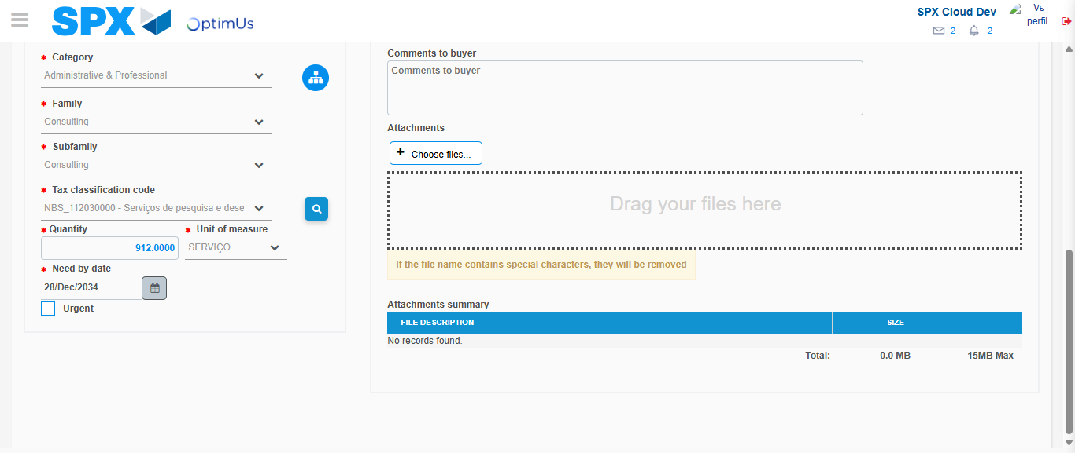Image file-name: QC_Testing-tc001_SPX_Dev5_Crear_Requisicion_Spot_Tipo_Cobro_CC-1788297762953

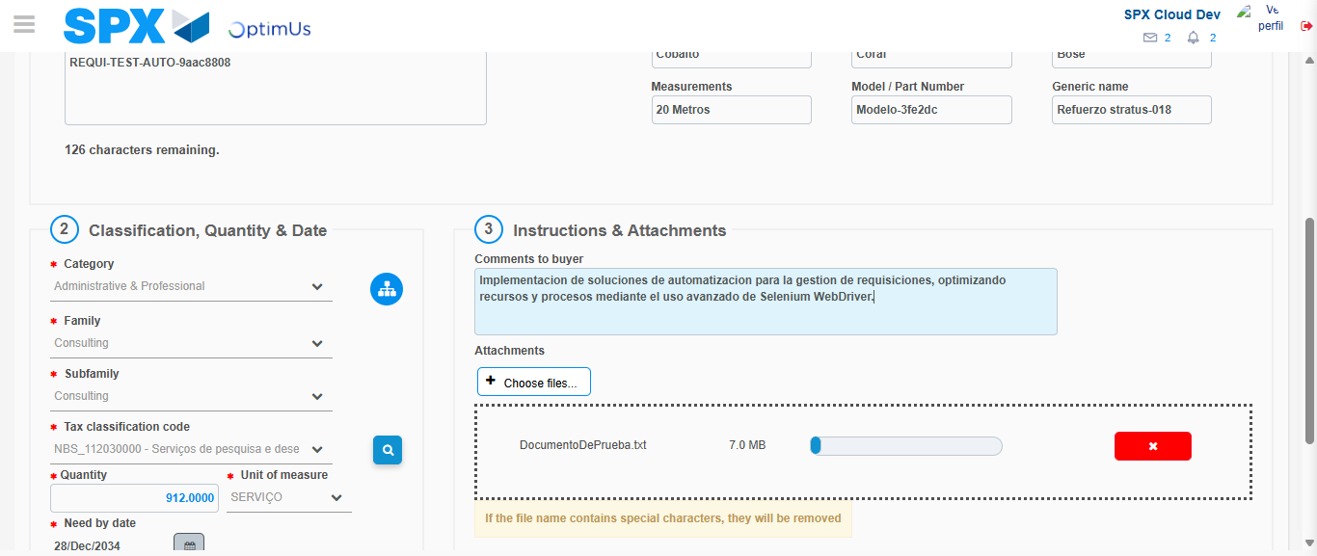Image file-name: QC_Testing-tc001_SPX_Dev5_Crear_Requisicion_Spot_Tipo_Cobro_CC-1788297763817

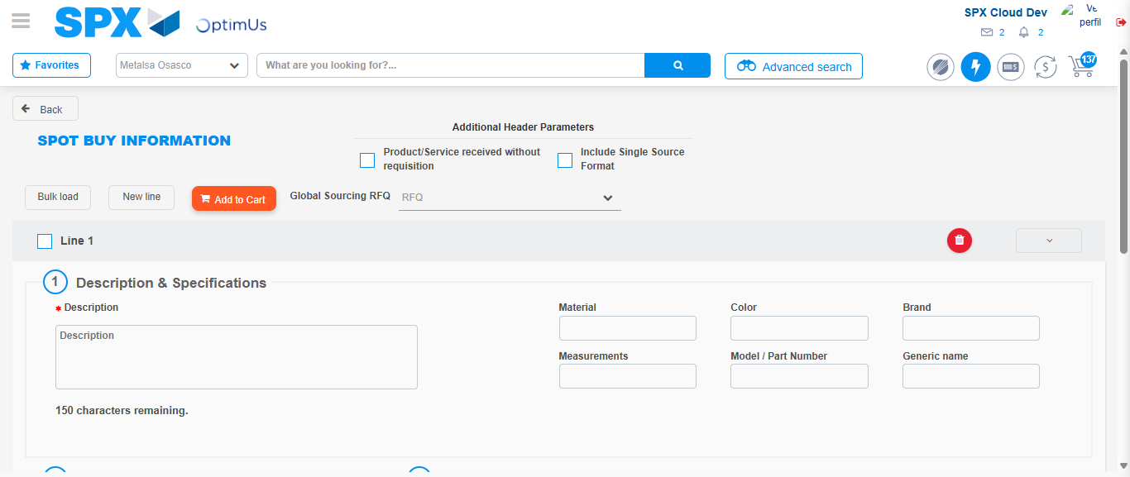Image file-name: QC_Testing-tc001_SPX_Dev5_Crear_Requisicion_Spot_Tipo_Cobro_CC-1788297769427

Step 7 - Return to Main Page SPX : Return to Main Page SPX
Image file-name: QC_Testing-tc001_SPX_Dev5_Crear_Requisicion_Spot_Tipo_Cobro_CC-1788297723867

Image file-name: QC_Testing-tc001_SPX_Dev5_Crear_Requisicion_Spot_Tipo_Cobro_CC-1788297724552

Image file-name: QC_Testing-tc001_SPX_Dev5_Crear_Requisicion_Spot_Tipo_Cobro_CC-1788297746781

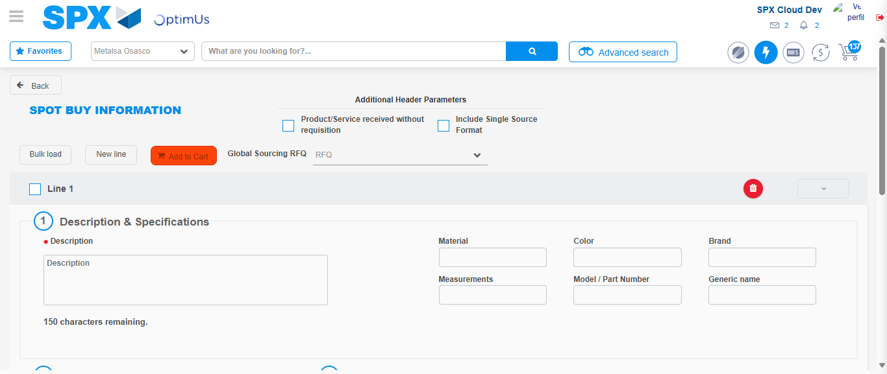Image file-name: QC_Testing-tc001_SPX_Dev5_Crear_Requisicion_Spot_Tipo_Cobro_CC-1788297771667

Image file-name: QC_Testing-tc001_SPX_Dev5_Crear_Requisicion_Spot_Tipo_Cobro_CC-1788297771849

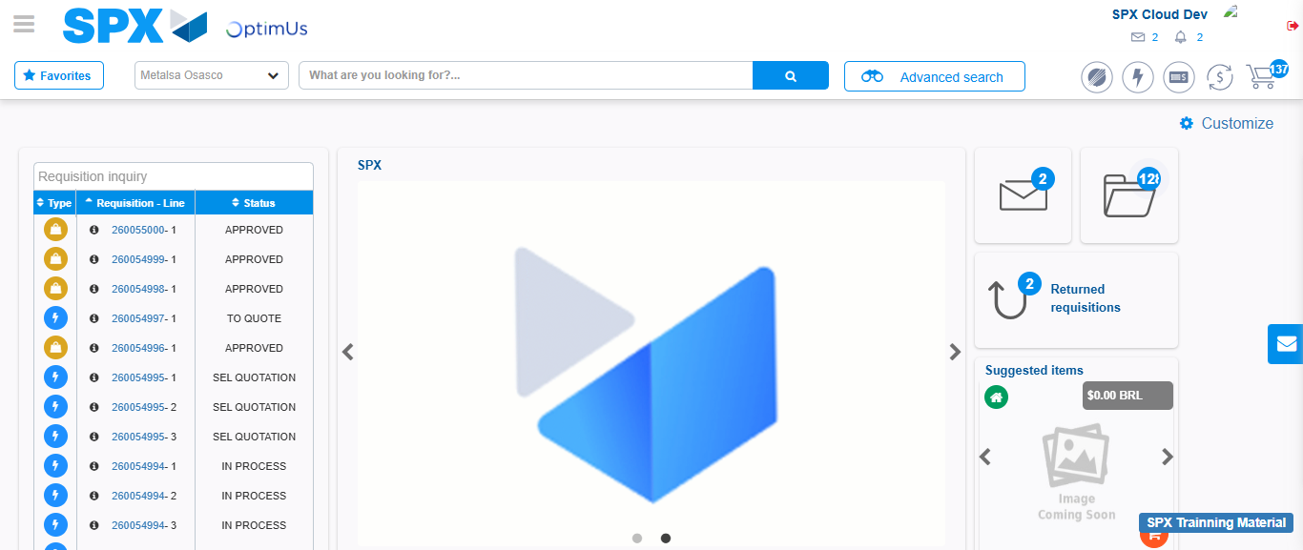Image file-name: QC_Testing-tc001_SPX_Dev5_Crear_Requisicion_Spot_Tipo_Cobro_CC-1788297793021

Step 8 - Log Out : Log Out SPX
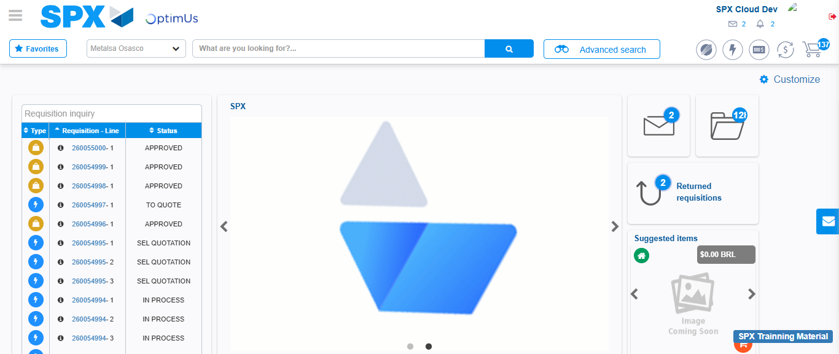Image file-name: QC_Testing-tc001_SPX_Dev5_Crear_Requisicion_Spot_Tipo_Cobro_CC-1788297793378

